Procedure to Stop Windchill, clean cache and Start Windchill - RH1
Schindler CRD Applications

Exported on 2025-08-19 05:09:16

Table of Contents

1 Prerequisite: 4
2 Procedure: 5
2.1 Procedure For Business Admins: 5
2.2 Procedure For System Admins: 6

- Prerequisite:
- Procedure:
  - Procedure For Business Admins:
  - Procedure For System Admins:

Prerequisite:
- User should have access to the Windchill Application server.

Procedure:

Procedure For Business Admins:
- Log into Windchill Application Server.
- To Stop the running Windchill, right click on WC-Stop.bat available on the Desktop and click on Run as Administrator.
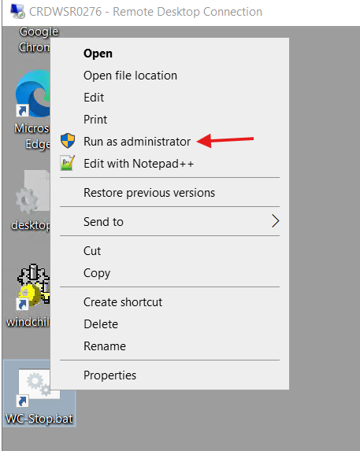
Note: Give minimum 5 min of time to stop all the method servers and execute the below step.

3. Now to clean cache, right click on WC-Cache-Cleanup.bat available on the Desktop and click on Run as Administrator.
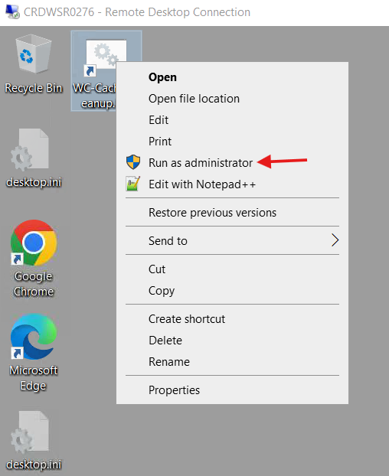

4. To start Windchill, right click on WC-Start.bat available on the Desktop and click on Run as Administrator.
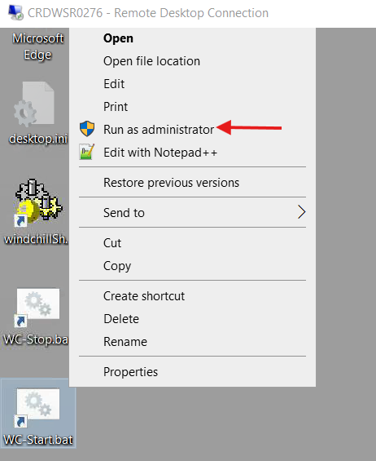

Procedure For System Admins:
- Log into Windchill Application Server.
- Launch Windows services.
- To stop the running Windchill,

  - Select PTC_Windchill service and click on Stop.
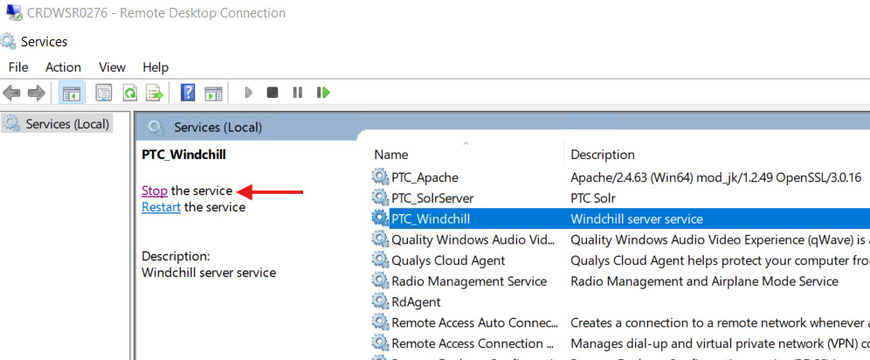

  - Select PTC_Apache service and click on Stop.
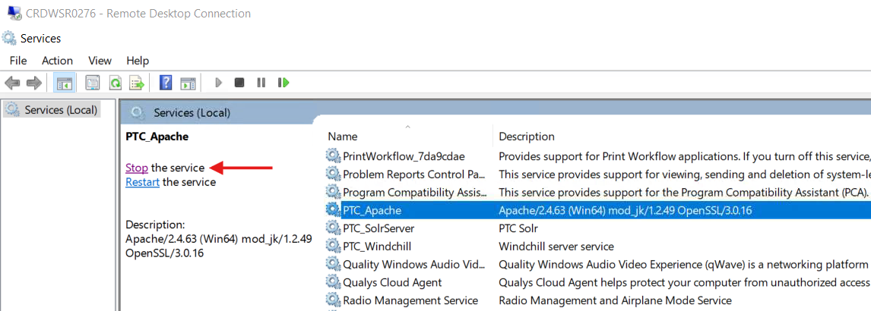

4. Now to clean cache, right click on WC-Cache-Cleanup.bat available on the Desktop and click on Run as Administrator.

5. To start the Windchill,

  - Select PTC_Apache service and click on Start.
  - Select PTC_Windchill service and click on Start.

